# Accessing other class object in method | [OOP in Python]

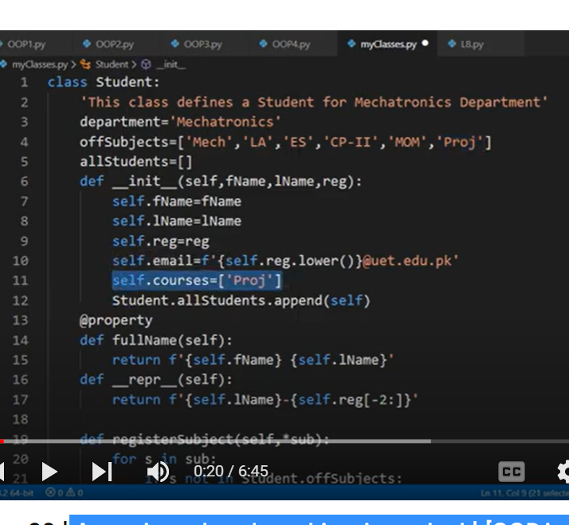

Proj is compulsory sub

But design project need 2 group members

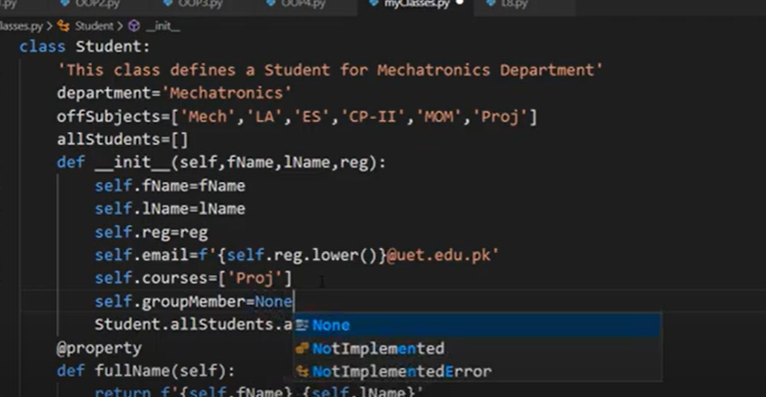

Set groupmember is none



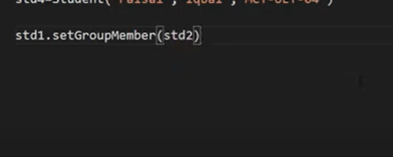

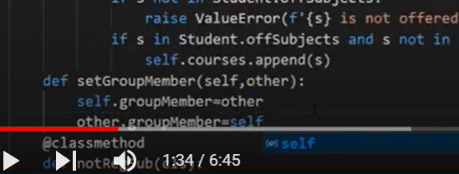

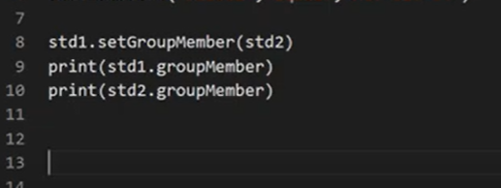

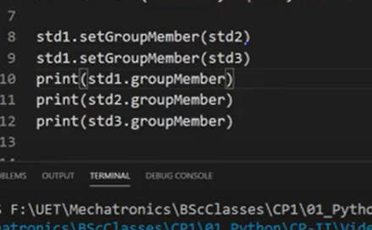

Here for stu1 has 2 group members

We need to apply conditions

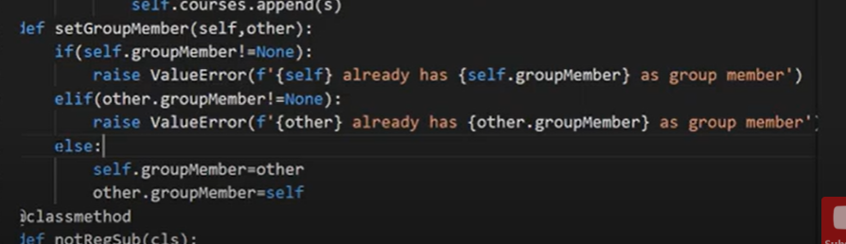

Now another method to drop group member

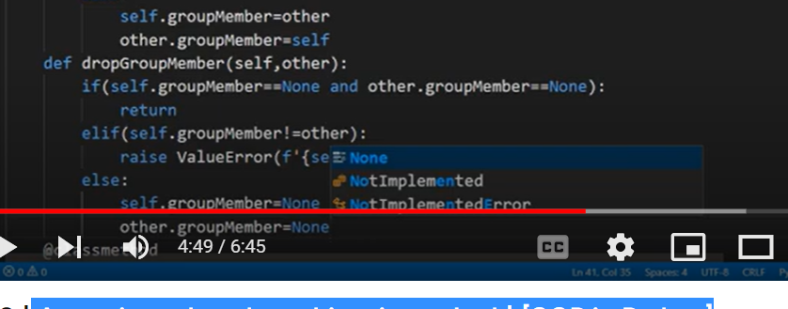

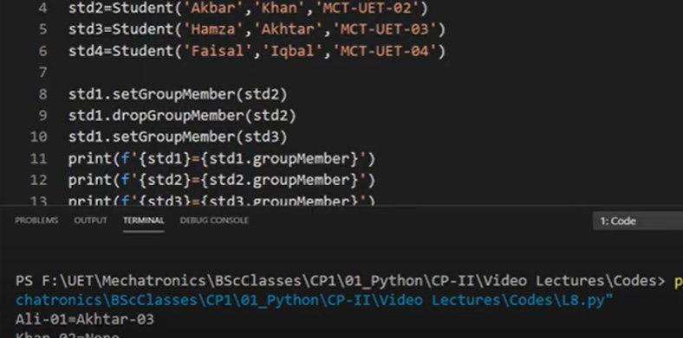

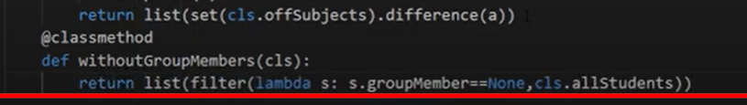

Encapsulation:

Data encapsulation:

Tech to hide data and prevents its access outside of class

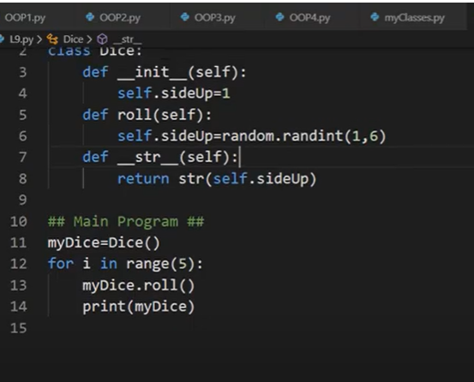

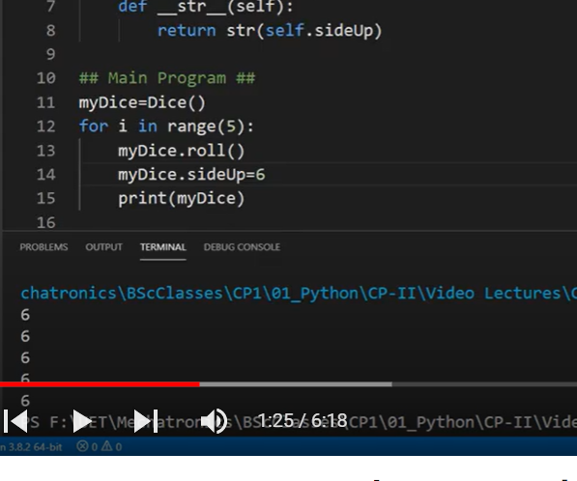

Now its fixed to 6

Miss use of method

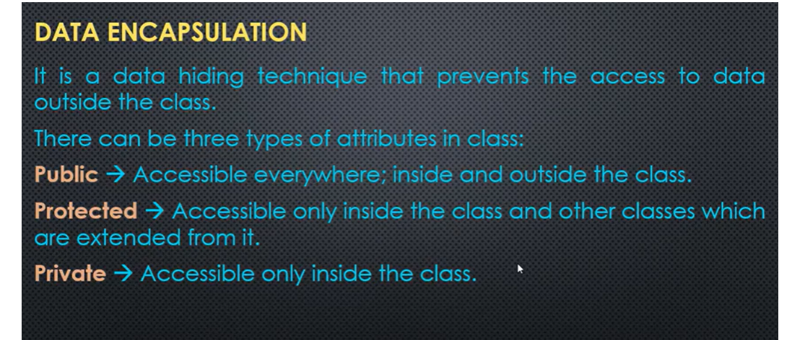

In python every attribute is public

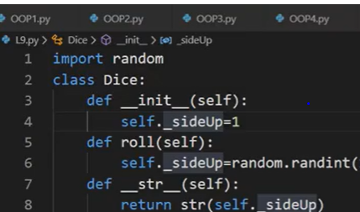

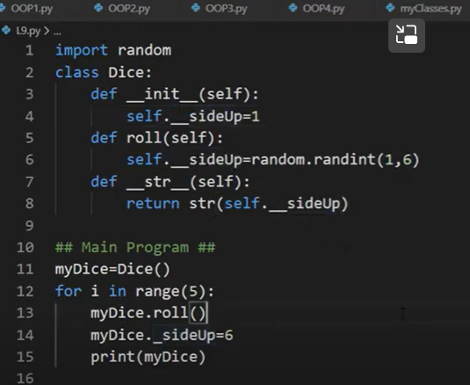

_ single underscore still change 6 all the time

__ double underscore

Don’t change

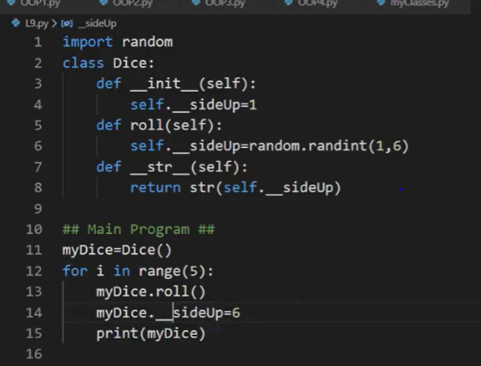

6 wont change

Python does name mangling to __ attributes

Which means it assign new name to it outside the class

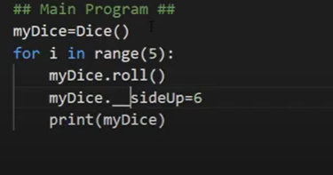

­­­­­­__sideup is not __sideup outside the classs

It has diff name outside of class

This will work

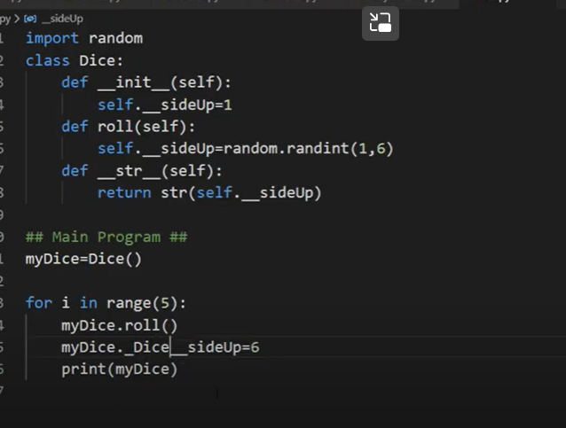

­­_class__sideup

-----------------------------------------------------------------------------

_ single undercore: reasonable indicator for developer not to access the attribute

__ doble underscore: strong indicator not to access

# Lesson-10 | Getters, Setters & Deleters |

# [OOP in Python]

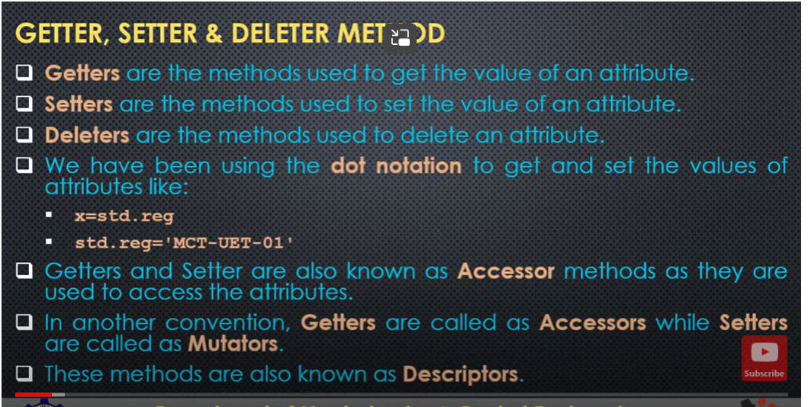

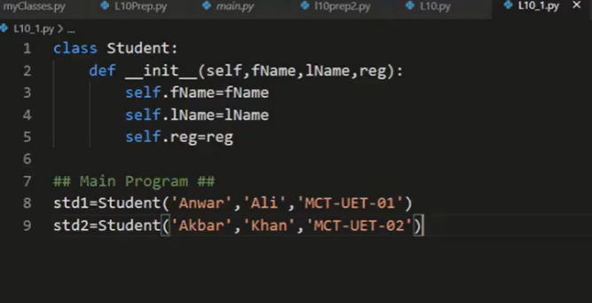

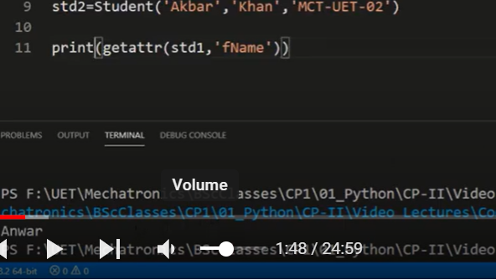

Build in method. Getter(obj, attribute)

For setter

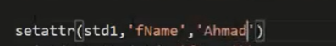

3 arguments:

Obj

Name of attribute

Name which we want to assign

We can use like this also

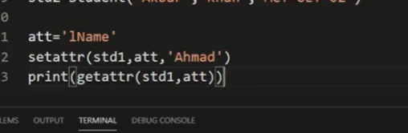

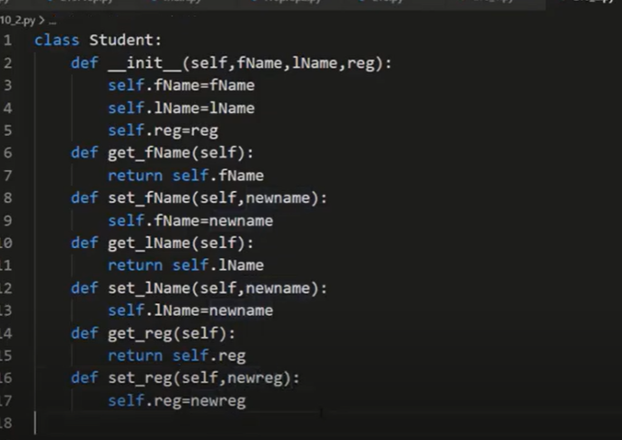

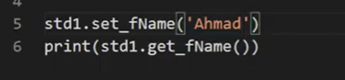

Set methods used to define condition for attribute as well

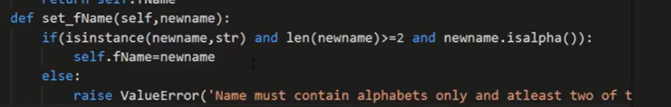

Even we can use same condition for l name

But using same logic for both methods not good idewa

We use static method to check the validity of name

This static method can be used in both set fname and set_lname

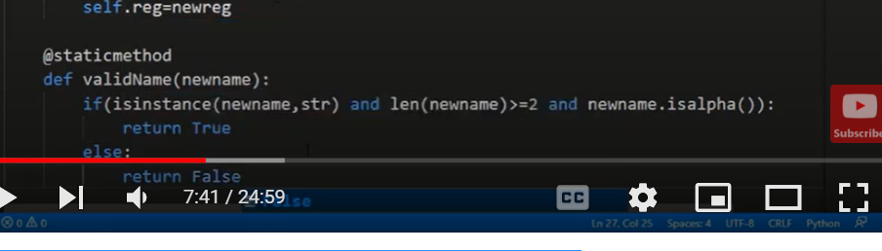

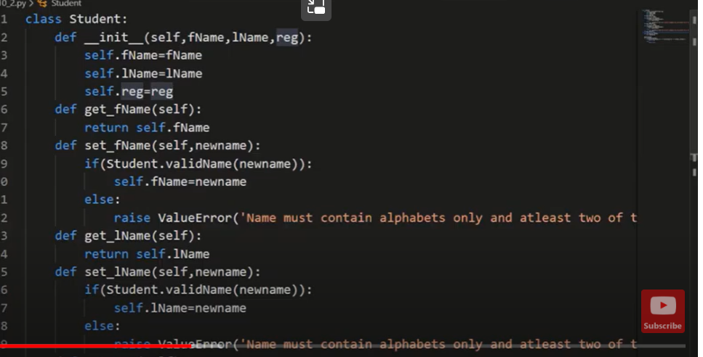

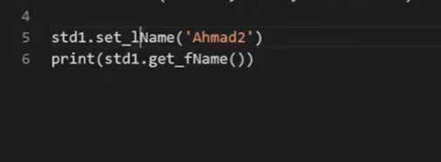

But when we create a obj with invalid name

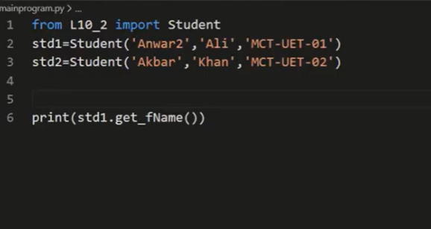

Anwar2

It wont raise value error

As it wont have validity checks and init method will be called

So we need to use set_fname inside init function

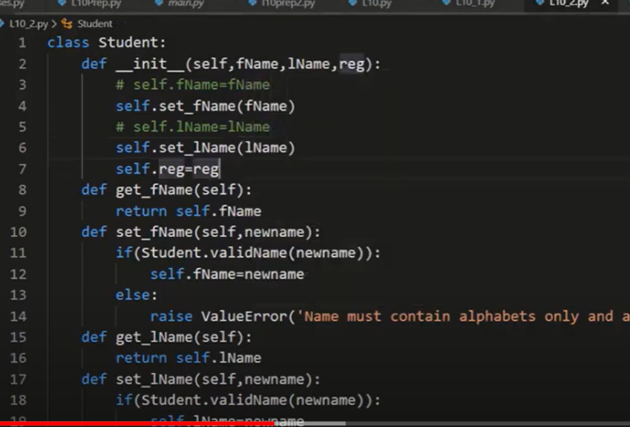

Extra benefit of getter method:

We can change format and shape of attribute while returning values

Name can be converted to upper

1. If we want to use property

The order of input is getter is first and setter s second

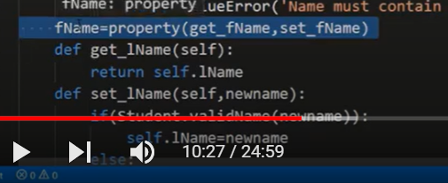

Polymorphism

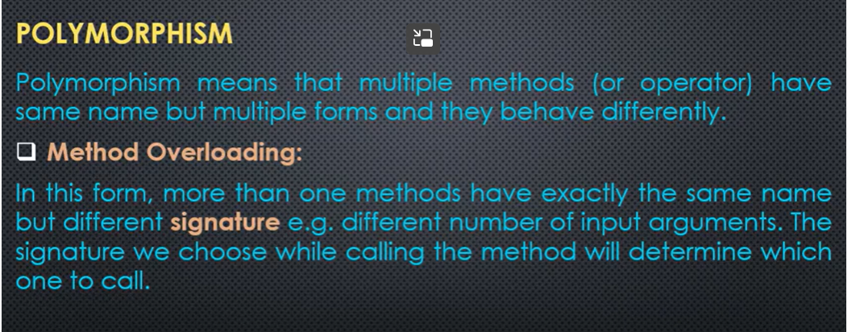

Python doesn’t support method overloading

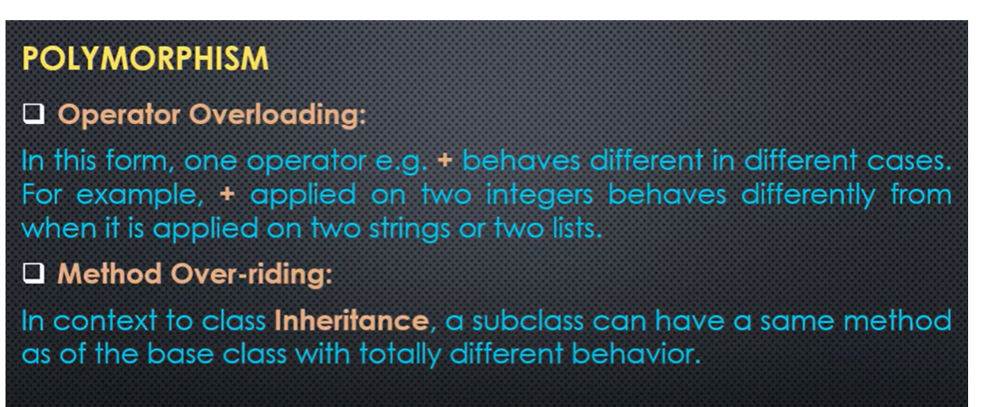

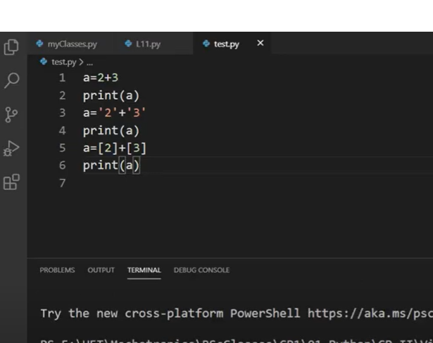

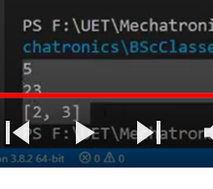

This is polymorphic behavior of + operator

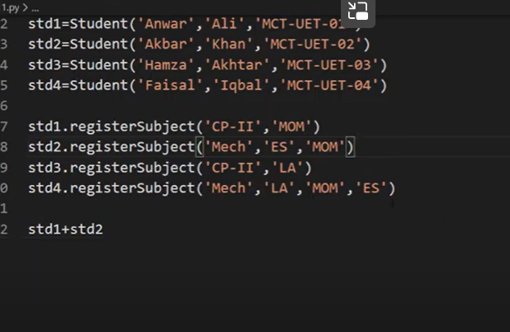

Here + operator will not work

To support + inside class

We need to add magic method

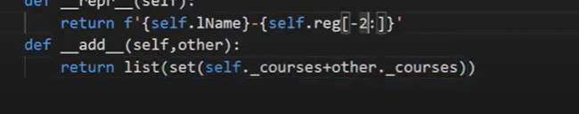

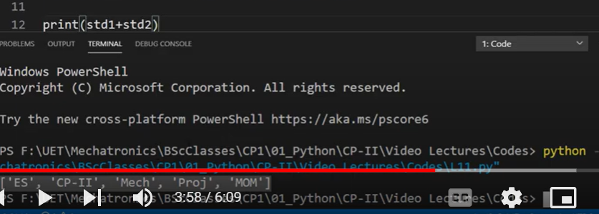

Now it will work

We can use add method for making group members

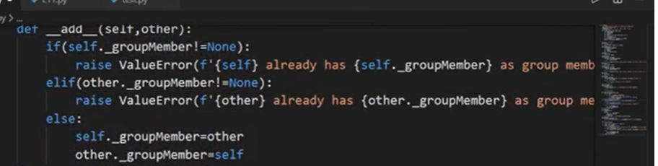

Same sub can be used to drop group member

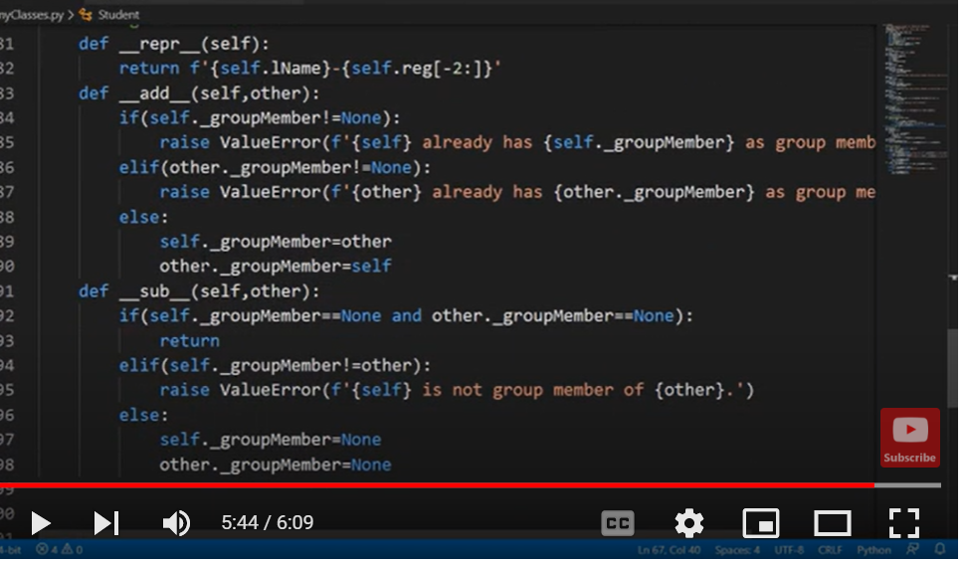

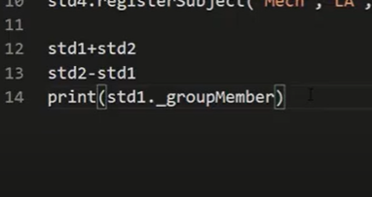

Comparisison magic methods

__ls__

Lessthan



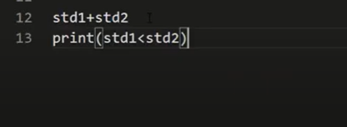

Equality



__le__ lessthan equal to



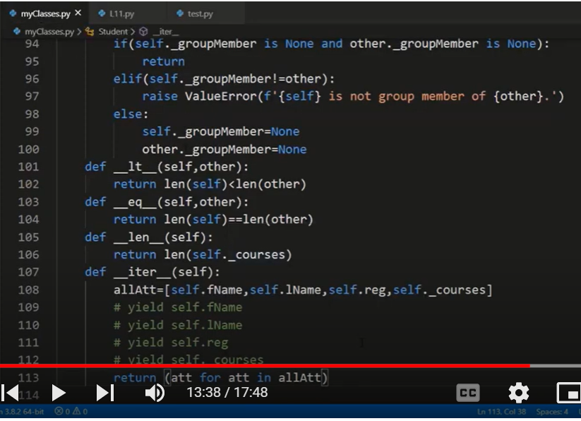

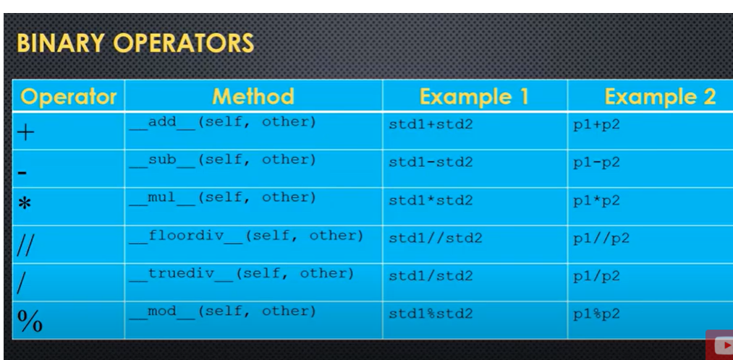

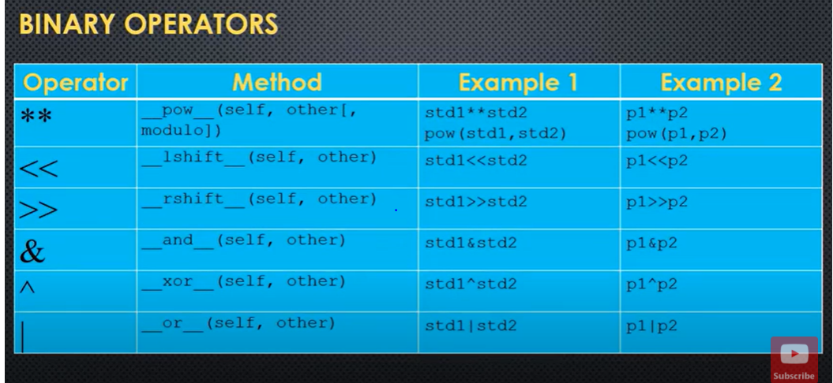

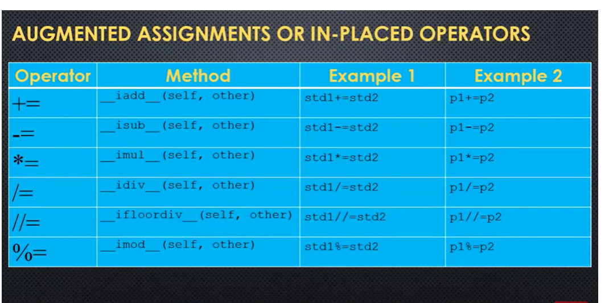

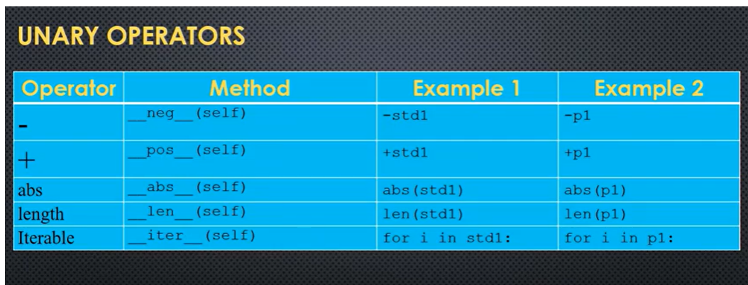

# Lesson-13 | NotImplemented & Reflection Function | [OOP in Python]